Uniform Policy
Contents
Policy Statement 2
Scope of the Policy 2
Issue of Uniform 2
General Maintenance 2
Return of Uniform 2
Non-band Use 2
Correct Wearing of Uniform 3
Personal presentation 9
Review and Updates 9
Policy Review 9

Policy Statement
Hampshire Caledonian Pipe Band (‘The Band’) issues all playing members with unform. This policy will assist playing members to turn out for engagements wearing the correct uniform and to promote a positive view of the band. The policy will also address the procedure for the issuing of uniforms and ensure that the standard and quantity of uniform is maintained.

Scope of the Policy
This policy applies to all playing members who are issued with band uniform.

Issue of Uniform
Uniform will only be issued to members of Hampshire Caledonian Pipe Band who are up to date with their membership fees.

Uniform will only be issued by the Quartermaster, upon the authorisation of the Pipe Major and Drum Major. Members must sign for uniform when issued.

Uniform is issued to an individual member and must not be loaned to another member of the band.

General Maintenance
Any loss or damage to any element of the uniform will incur a charge to the individual. Replacements will be purchased by the Quartermaster from the designated manufacturers. Individuals will not buy the replacement themselves.

Return of Uniform
If the return of uniform is requested by the committee, uniform must be returned within 14 days of the request. All uniform must be returned to the Quartermaster.
Any outstanding or lost items of uniform will incur a charge.

Non-band Use
Uniform may be used for non-band purposes (i.e., private wear or for when performing with other bands) with the permission of the Pipe Major/Drum Major.
Members wearing band uniform for private paid functions are required to pay a 10% service charge of the fee paid for the function.

Correct Wearing of Uniform
Correct wear of the uniform will be outlined in guidelines below, along with images.
Glengarry
- Black Glengarry issued by the band
- Hair is not to show from the front of the glengarry
- Point of the Glengarry should be in line with the centre of your nose
- There should be a two-finger gap between your eyebrows and the bottom of the Glengarry
- The tapes at the back should be pressed regularly to remove any creases - Use a hot steam iron or a soaked cloth. Do not iron directly onto the tapes as this will make them shiny
Cap badge
- Cap badge issued by the band
- Cap badge is to be worn over the ribbon of the Glengarry
- Secured with clear thread, as illustrated
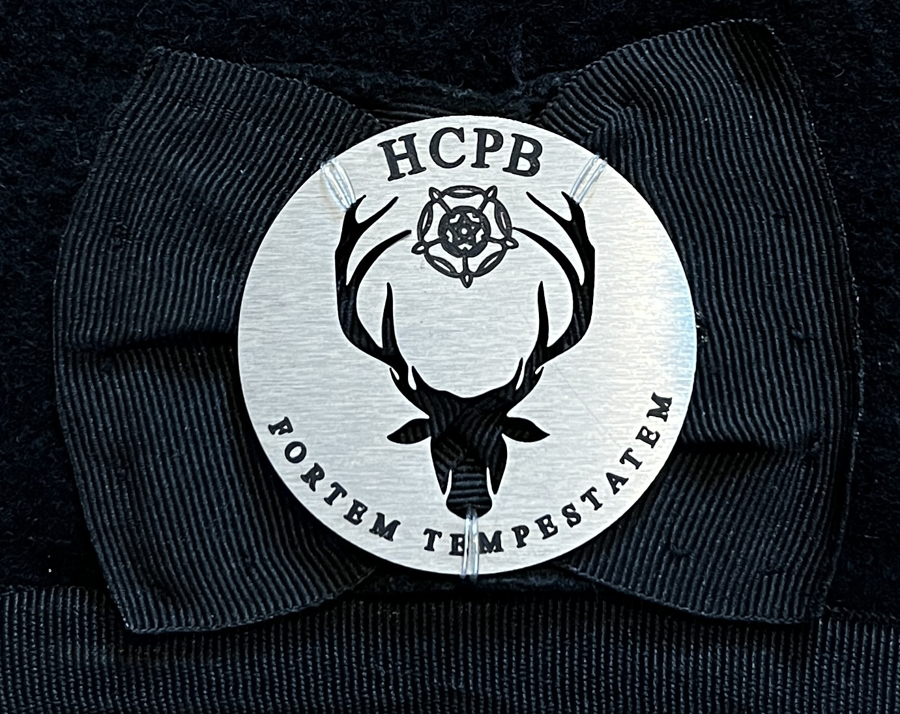

Hackle
- Blue/grey hackle issued by the band
- Worn behind the cap badge
- Worn at all engagements unless informed otherwise by Pipe Major/Drum Major
- Not to be worn in the rain
- When not being worn, hackles are to be stored in the tubing and clear wallet supplied
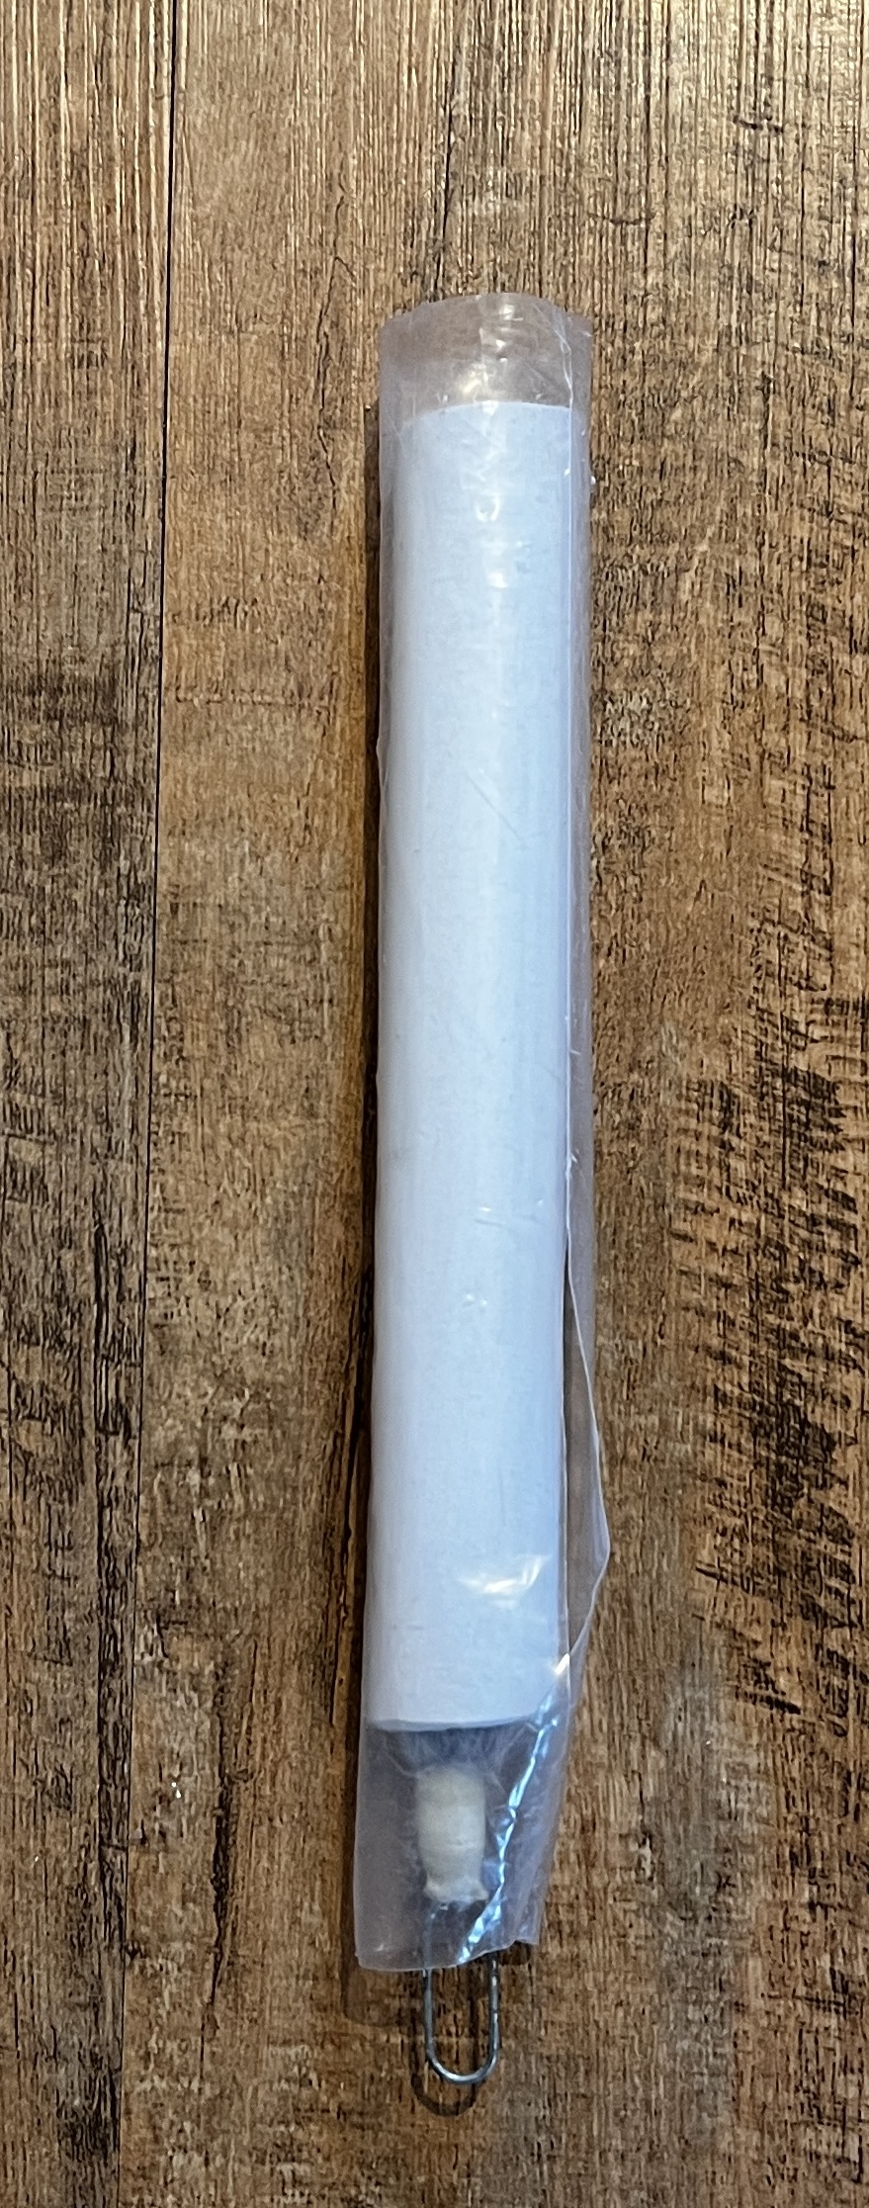

Tie
- Stripped tie issued by the band
- Windsor knot – see instructions below, or Pipe Major for lesson
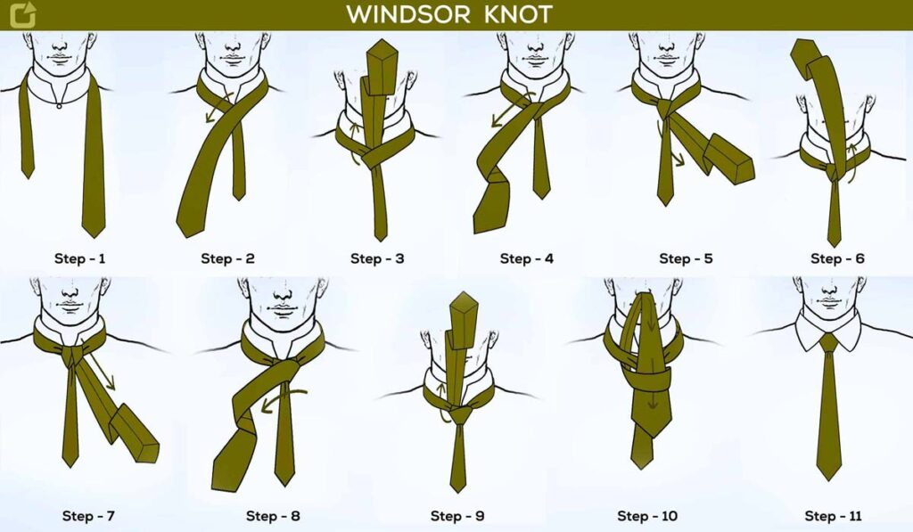
Shirt
- Black long-sleeved shirts to be worn – private purchase by member
- No patches or badges to be worn on the shirt
- Shirts are to be pressed
- During summer months, it may be at the Pipe Major/Drum Major’s discretion as to whether sleeves can be rolled up
- Personal/private purchase cufflinks can be worn
Waistcoat
- Black waistcoat with silver buttons issued by the band
- If buttons fall off, they are to be replaced ASAP. See the Quartermaster for replacement buttons – to be sewn on by the individual
- Bottom button not to be done up
- No badges or items to be worn on the waistcoat unless sanctioned by the Pipe Major. Items that are allowed include:
  - Poppy badge for Remembrance
- Pocket watch and chain not to be worn
Jacket
- Black jacket with silver buttons issued by the band
- To be left unbuttoned
- If buttons fall off, they are to be replaced ASAP. See the Quartermaster for replacement buttons – to be sewn on by the individual
- Jackets are worn at the discretion of the Pipe Major/Drum Major.
- No badges to be worn
- Medals and ribbons can be worn on ceremonial occasions
Sporran
- Black sporran with chain strap issued by the band
- Chain strap issued by the band must be worn
- Centre of the sporran should be in line with the centre line of the kilt (Except drummers when playing)
Belt
- Belt buckle issued by the band
- Belt is a private purchase
- Buckle should be in line with the centre of the kilt
Kilt
Tartan: Kintyre Storm
- Issued by the band, with the option to purchase from the band
- To be worn with the hem just above the knee
- Centre line of the kilt should be in line with the point of the tie and buttons on the shirt and should be directly in the centre when standing to attention
- No kilt pins to be worn. This is due to equipment (i.e., drums) having the potential to catch kilt pins when being removed from the harness, causing subsequent damage to the kilt
Flashes
- Kintyre Strom tartan flashes, mounted on elastic garters issued by the band
- To be worn with the front edge towards the middle of the front of the shin
- To be kept pressed and flat at all times
Hose
- Charcoal grey hose issued by the band - Playing members are issued with 1 set, although additional sets may be privately purchased through the band
- There should be a two-finger gap between the bottom of your knee and the top of the hose
Ghillie Brogues
- Brogues or Ghillie Brogues must be worn - Black, private purchase
- To be clean and polished at all times
- Laces are to be tied as follows:
  - Tie half of a bow
  - Twist laces 3 times
  - Pass around back of leg wrap around ankle/leg
  - Tie in a bow to the outside of the center of the shin
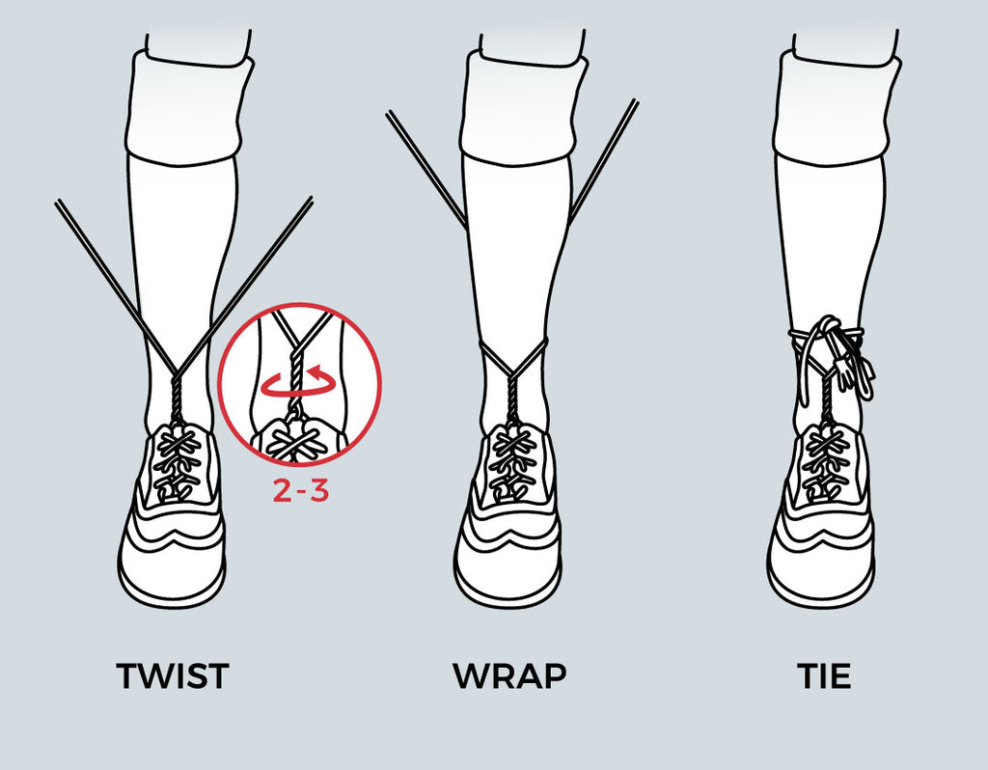
Cape
- Black cape issued by the band
- To be kept clean and free of dirt
- To be taken to all engagements and worn if raining
- Capes can be worn in their pouches, on the belt strap if rain is suspected, at the Pipe Major/Drum Major’s discretion

Sgian Dhu
- Private purchase item
- To be worn on the right leg on the outside center of the leg
Policies applicable to pipers only:
Bagpipes
- Own private purchase
Bag covers
- Navy blue bag covers issued by the band
- These are considered to be uniform and must be used at all band engagements
- Nothing (i.e., patches) should be added to the band bag cover
Cords
- Silver cords issued by the band
- Cords should be kept in good order and free of loose thread
- To be fitted with cable ties or thread
Chanters
- Suter chanter issued by band
- Members may privately purchase G1 platinum chanter
- It is asked that these are left set for Hampshire Caledonian Pipe Band purposes
Drone Valves
- Issued by the band
Policies applicable to drummers only:
Drums
- Blue/white/silver Andante drums issued by the band
- To be kept clean and in working order at all times
- Breakages must be reported to the Drum Major ASAP
- When not in use, drums are to be placed in cases and kept dry
- Drums to be stored in a suitable area of the home (dry and not next to a radiator, in the conservatory, or left in car). Drums can be stored at practice venue if necessary
- Drums are NOT to be used for playing with other bands, unless agreed by the Drum Major
Harnesses
- Issued by the band
- To be kept clean and in working order at all times
- Breakages must be reported to the Drum Major ASAP
Sticks
- Plain sticks issued by the band
- Blue tenor/bass mallets issued by the band
- Blue tenor mallets are to be used for performances only. Alternative sticks to be used for practices to maintain the quality of performance mallets

Personal presentation
All long hair to be kept tied back, free of the face.

Review and Updates
The Committee shall undertake to review this policy, its implementation and effectiveness on an annual basis.

Policy Review

Date reviewed | Comments | Reviewed by
22/09/25 | Agreed for introduction – images to follow. | Committee

